Tutorial 2-1:

close all

clear all

clc

% Define parameters

C = 2e-9; % Membrane capacitance (F)

R = 5*1e6; % Membrane resistance (?)

leak_potential = -70e-3; % Leak potential (V)

threshold = -50e-3; % Spike threshold (V)

reset_potential = -65e-3; % Reset potential (V)

dt = 0.1e-3; % Time step (s)

T = 2; % Maximum time (s)

% Create time vector

t = 0:dt:T;

% I define the I_app and the loop after that in Iapp function

I_th = (threshold - leak_potential)/R;

I_lower = I_th*0.99;

[I_app_lower,v_lower] = Iapp(I_lower, t,leak_potential,C,R,dt,threshold,reset_potential);

I_higher = I_th*1.01;

[I_app_higher,v_higher] = Iapp(I_higher, t,leak_potential,C,R,dt,threshold,reset_potential);

img=figure;

plot(t(1:2001), v_lower(1:2001), 'b', 'LineWidth', 2);

hold on;

plot(t(1:2001), v_higher(1:2001), 'r', 'LineWidth', 2);

xlabel('Time (s)');

ylabel('Membrane Potential (V)');

title('Membrane Potential with Different Applied Currents');

legend('slightly lower than','slightly higher than','Location','SouthEast');

grid on;

saveas(img, sprintf('Tutorial_2_1_question_1b.png'));

%Lower Current: I_low doesn't produce spikes, the calculation and simulation confirm the minimum current threshold for spiking.

%Higher Current:I_high produces spikes, it verifies that currents above the threshold trigger spiking behavior.

Tau = C*R;

i_0 = [I_th*1.05 I_th*1.1 I_th*1.15 I_th*1.2 I_th*1.25 I_th*1.30 I_th*1.25 I_th*1.35 I_th*1.4 I_th*1.45];

frates = zeros(size(i_0));

k=1;

for I_0 = i_0

[I_app_f,v_f] = Iapp(I_0, t, leak_potential, C, R, dt, threshold, reset_potential);

spike_count = 0;

for n = 1:length(v_f)

if v_f(n) == reset_potential;

spike_count = spike_count + 1;

end

end

rate = spike_count/2;

frates(k) = rate;

k=k+1;

end

img1=figure

scatter(i_0, frates);

xlabel('I_app');

ylabel('Firing rate(Hz)');

title('Firing rate based on injected current 1c');

legend('1c','Location','SouthEast');

grid on;

saveas(img1, sprintf('Tutorial_2_1_question_1c.png'));

f=zeros(size(i_0));

j=1;

for I_0 = i_0

if ((leak_potential + R * Iapp(I_0, t, leak_potential, C, R, dt, threshold, reset_potential) - reset_potential) > 0) & ...

((leak_potential + R * Iapp(I_0, t, leak_potential, C, R, dt, threshold, reset_potential) - threshold) > 0)

firing_rate = 1 / (Tau * log((leak_potential + R * Iapp(I_0, t, leak_potential, C, R, dt, threshold, reset_potential) - reset_potential) / ...

(leak_potential + R * Iapp(I_0, t, leak_potential, C, R, dt, threshold, reset_potential) - threshold)));

end

f(j) = firing_rate;

j = j + 1;

end

img2=figure

scatter(i_0, frates);

hold on

scatter(i_0, f);

xlabel('I_app');

ylabel('Firing rate(Hz)');

title('Firing rate based on injected current');

legend('1c','1d','Location','SouthEast');

grid on;

saveas(img2, sprintf('Tutorial_2_1_question_1d.png'));

sigma=[0.1,0.2]

I_lower = I_th*0.99;

[I_app_lower_n,v_lower_n] = n_Iapp(I_lower, t,leak_potential,C,R,dt,threshold,reset_potential,sigma(1));

I_higher = I_th*1.01;

[I_app_higher_n,v_higher_n] = n_Iapp(I_higher, t,leak_potential,C,R,dt,threshold,reset_potential,sigma(1));

img3=figure;

plot(t(1:2001), v_lower(1:2001), 'b', 'LineWidth', 2);

hold on;

plot(t(1:2001), v_higher(1:2001), 'r', 'LineWidth', 2);

hold on

plot(t(1:2001), v_lower_n(1:2001), 'g', 'LineWidth', 2);

hold on;

plot(t(1:2001), v_higher_n(1:2001), 'c', 'LineWidth', 2);

xlabel('Time (s)');

ylabel('Membrane Potential (V)');

title('Membrane Potential with Different Applied Currents in presense of noise');

legend('slightly lower than','slightly higher than','slightly lower than-with noise','slightly higher than-with noise','Location','SouthEast');

grid on;

saveas(img3, sprintf('Tutorial_2_1_question_2a_1.png'));

n_frates = zeros(length(i_0),length(sigma));

k=1;

l=1;

for sigma_I=sigma

for I_0 = i_0

[I_app_f,v_f] = n_Iapp(I_0, t, leak_potential, C, R, dt, threshold, reset_potential,sigma_I);

spike_count = 0;

for n = 1:length(v_f)

if v_f(n) == reset_potential;

spike_count = spike_count + 1;

end

end

rate = spike_count/2;

n_frates(k,l) = rate;

k=k+1;

end

k=1;

l=l+1;

end

f_n=zeros(length(i_0),length(sigma));

j=1;

w=1;

for sigma_I=sigma

for I_0 = i_0

if ((leak_potential + R * Iapp(I_0, t, leak_potential, C, R, dt, threshold, reset_potential) - reset_potential) > 0) & ...

((leak_potential + R * Iapp(I_0, t, leak_potential, C, R, dt, threshold, reset_potential) - threshold) > 0)

firing_rate = 1 / (Tau * log((leak_potential + R * Iapp(I_0, t, leak_potential, C, R, dt, threshold, reset_potential) - reset_potential) / ...

(leak_potential + R * Iapp(I_0, t, leak_potential, C, R, dt, threshold, reset_potential) - threshold)));

end

f_n(j,w) = firing_rate;

j = j + 1;

end

j=1;

w=w+1

end

img4=figure

scatter(i_0, frates, 'SizeData', 52);

hold on

scatter(i_0, f, 'SizeData', 52);

hold on

scatter(i_0, n_frates(:,1), 'Marker', '*', 'SizeData', 52);

hold on

scatter(i_0, f_n(:,1), 'Marker', '*', 'SizeData', 52);

hold on

scatter(i_0, n_frates(:,2), 'Marker', 's', 'SizeData', 52);

hold on

scatter(i_0, f_n(:,2), 'Marker', 's', 'SizeData',52);

xlabel('I_app');

ylabel('Firing rate(Hz)');

title('Firing rate based on injected current');

legend('1c-sigma=0','1d-sigma=0','1c-sigma=0.1','1d-sigma=0.1','1c-sigma=0.2','1d-sigma=0.2','Location','SouthEast');

grid on;

saveas(img4, sprintf('Tutorial_2_1_question_2a.png'));

%%%%%%%%%%%%%%%%%%%%%%

%%%%%%%%%%%%%%%%%%%%%%%%%%%%%

dt = 0.01e-3; % Time step (s)

T = 2; % Maximum time (s)

% Create time vector

t = 0:dt:T;

% I define the I_app and the loop after that in Iapp function

I_th = (threshold - leak_potential)/R;

I_lower = I_th*0.99;

[I_app_lower,v_lower] = Iapp(I_lower, t,leak_potential,C,R,dt,threshold,reset_potential);

I_higher = I_th*1.01;

[I_app_higher,v_higher] = Iapp(I_higher, t,leak_potential,C,R,dt,threshold,reset_potential);

img5=figure;

plot(t(1:2001), v_lower(1:2001), 'b', 'LineWidth', 2);

hold on;

plot(t(1:2001), v_higher(1:2001), 'r', 'LineWidth', 2);

xlabel('Time (s)');

ylabel('Membrane Potential (V)');

title('Membrane Potential with Different Applied Currents');

legend('slightly lower than','slightly higher than','Location','SouthEast');

grid on;

saveas(img5, sprintf('Tutorial_2_1_question_2c_1.png'));

%Lower Current: I_low doesn't produce spikes, the calculation and simulation confirm the minimum current threshold for spiking.

%Higher Current:I_high produces spikes, it verifies that currents above the threshold trigger spiking behavior.

Tau = C*R;

i_0 = [I_th*1.05 I_th*1.1 I_th*1.15 I_th*1.2 I_th*1.25 I_th*1.30 I_th*1.25 I_th*1.35 I_th*1.4 I_th*1.45];

frates = zeros(size(i_0));

k=1;

for I_0 = i_0

[I_app_f,v_f] = Iapp(I_0, t, leak_potential, C, R, dt, threshold, reset_potential);

spike_count = 0;

for n = 1:length(v_f)

if v_f(n) == reset_potential;

spike_count = spike_count + 1;

end

end

rate = spike_count/2;

frates(k) = rate;

k=k+1;

end

img1=figure

scatter(i_0, frates);

xlabel('I_app');

ylabel('Firing rate(Hz)');

title('Firing rate based on injected current 1c');

legend('1c','Location','SouthEast');

grid on;

saveas(img1, sprintf('Tutorial_2_1_question_1c.png'));

f=zeros(size(i_0));

j=1;

for I_0 = i_0

if ((leak_potential + R * Iapp(I_0, t, leak_potential, C, R, dt, threshold, reset_potential) - reset_potential) > 0) & ...

((leak_potential + R * Iapp(I_0, t, leak_potential, C, R, dt, threshold, reset_potential) - threshold) > 0)

firing_rate = 1 / (Tau * log((leak_potential + R * Iapp(I_0, t, leak_potential, C, R, dt, threshold, reset_potential) - reset_potential) / ...

(leak_potential + R * Iapp(I_0, t, leak_potential, C, R, dt, threshold, reset_potential) - threshold)));

end

f(j) = firing_rate;

j = j + 1;

end

img6=figure

scatter(i_0, frates);

hold on

scatter(i_0, f);

xlabel('I_app');

ylabel('Firing rate(Hz)');

title('Firing rate based on injected current');

legend('1c','1d','Location','SouthEast');

grid on;

saveas(img6, sprintf('Tutorial_2_1_question_2c_2.png'));

sigma=[0.1,0.2]

I_lower = I_th*0.99;

[I_app_lower_n,v_lower_n] = n_Iapp(I_lower, t,leak_potential,C,R,dt,threshold,reset_potential,sigma(1));

I_higher = I_th*1.01;

[I_app_higher_n,v_higher_n] = n_Iapp(I_higher, t,leak_potential,C,R,dt,threshold,reset_potential,sigma(1));

img7=figure;

plot(t(1:2001), v_lower(1:2001), 'b', 'LineWidth', 2);

hold on;

plot(t(1:2001), v_higher(1:2001), 'r', 'LineWidth', 2);

hold on

plot(t(1:2001), v_lower_n(1:2001), 'g', 'LineWidth', 2);

hold on;

plot(t(1:2001), v_higher_n(1:2001), 'c', 'LineWidth', 2);

xlabel('Time (s)');

ylabel('Membrane Potential (V)');

title('Membrane Potential with Different Applied Currents in presense of noise');

legend('slightly lower than','slightly higher than','slightly lower than-with noise','slightly higher than-with noise','Location','SouthEast');

grid on;

saveas(img7, sprintf('Tutorial_2_1_question_2c_3.png'));

n_frates = zeros(length(i_0),length(sigma));

k=1;

l=1;

for sigma_I=sigma

for I_0 = i_0

[I_app_f,v_f] = n_Iapp(I_0, t, leak_potential, C, R, dt, threshold, reset_potential,sigma_I);

spike_count = 0;

for n = 1:length(v_f)

if v_f(n) == reset_potential;

spike_count = spike_count + 1;

end

end

rate = spike_count/2;

n_frates(k,l) = rate;

k=k+1;

end

k=1;

l=l+1;

end

f_n=zeros(length(i_0),length(sigma));

j=1;

w=1;

for sigma_I=sigma

for I_0 = i_0

if ((leak_potential + R * Iapp(I_0, t, leak_potential, C, R, dt, threshold, reset_potential) - reset_potential) > 0) & ...

((leak_potential + R * Iapp(I_0, t, leak_potential, C, R, dt, threshold, reset_potential) - threshold) > 0)

firing_rate = 1 / (Tau * log((leak_potential + R * Iapp(I_0, t, leak_potential, C, R, dt, threshold, reset_potential) - reset_potential) / ...

(leak_potential + R * Iapp(I_0, t, leak_potential, C, R, dt, threshold, reset_potential) - threshold)));

end

f_n(j,w) = firing_rate;

j = j + 1;

end

j=1;

w=w+1

end

img8=figure

scatter(i_0, frates, 'SizeData', 52);

hold on

scatter(i_0, f, 'SizeData', 52);

hold on

scatter(i_0, n_frates(:,1), 'Marker', '*', 'SizeData', 52);

hold on

scatter(i_0, f_n(:,1), 'Marker', '*', 'SizeData', 52);

hold on

scatter(i_0, n_frates(:,2), 'Marker', 's', 'SizeData', 52);

hold on

scatter(i_0, f_n(:,2), 'Marker', 's', 'SizeData',52);

xlabel('I_app');

ylabel('Firing rate(Hz)');

title('Firing rate based on injected current');

legend('1c-sigma=0','1d-sigma=0','1c-sigma=0.1','1d-sigma=0.1','1c-sigma=0.2','1d-sigma=0.2','Location','SouthEast');

grid on;

saveas(img8, sprintf('Tutorial_2_1_question_2c_4.png'));

Functions I used in the code:

function [I_app,v] = Iapp(I_0, t,leak_potential,C,R,dt,threshold,reset_potential)

v =zeros(size(t));

v(1) = leak_potential;

I_app = I_0*ones(size(t));

for i = 2:length(t)

% Update membrane potential with Forward Euler

v(i) = v(i-1) + dt * ((leak_potential-v(i-1)) / R + I_app(i)) / C;

% Check for and reset spike

if v(i) >= threshold

v(i) = reset_potential;

end

end

end

function [I_app_n,v_n] = n_Iapp(I_0, t,leak_potential,C,R,dt,threshold,reset_potential,sigma_I)

v_n =zeros(size(t));

v_n(1) = leak_potential;

I_app_n = I_0*ones(size(t));

noise_vec = randn(size(t))*sigma_I*sqrt(dt);

for i = 2:length(t)

% Update membrane potential with Forward Euler

v_n(i) = (v_n(i-1) + dt * ((leak_potential-v_n(i-1)) / R + I_app_n(i)) / C)+noise_vec(i);

% Check for and reset spike

if v_n(i) >= threshold

v_n(i) = reset_potential;

end

end

end

The simulation graphs:

1.

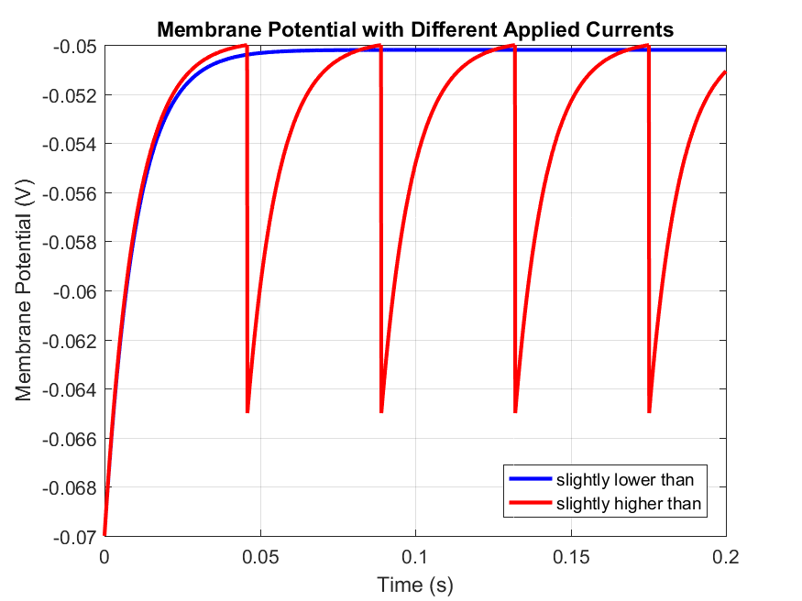

Lower Current: I_low doesn't produce spikes, the calculation and simulation confirm the minimum current threshold for spiking.

Higher Current:I_high produces spikes, it verifies that currents above the threshold trigger spiking behavior.

1.C.

1.D.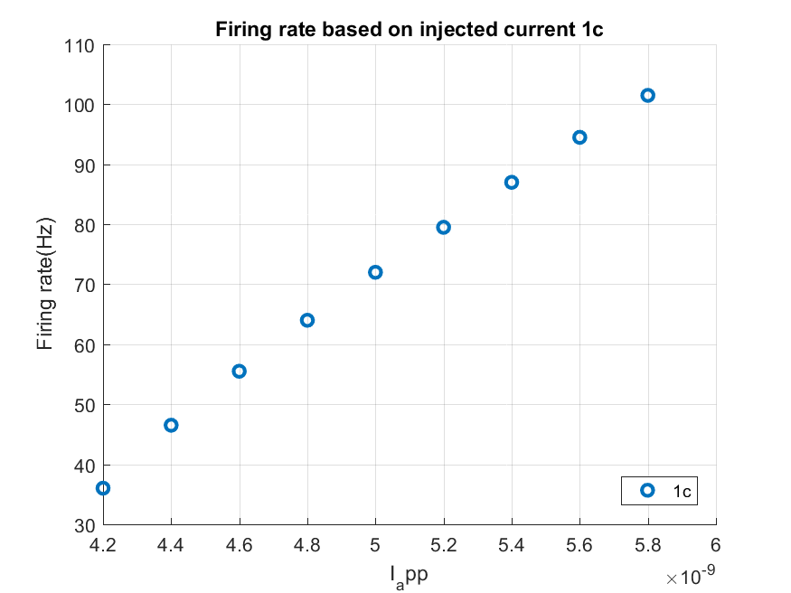

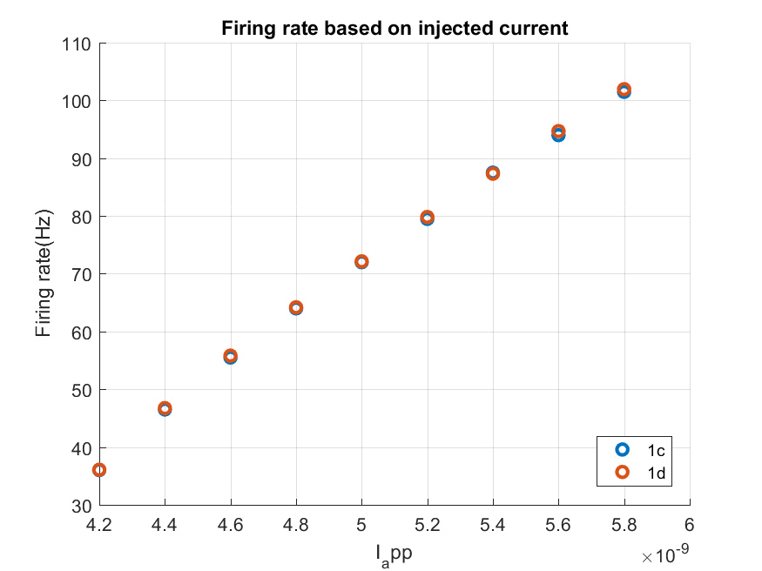

I can observe the different firing rates between the theoretical and estimated f_I curve.

2.a: adding noise.

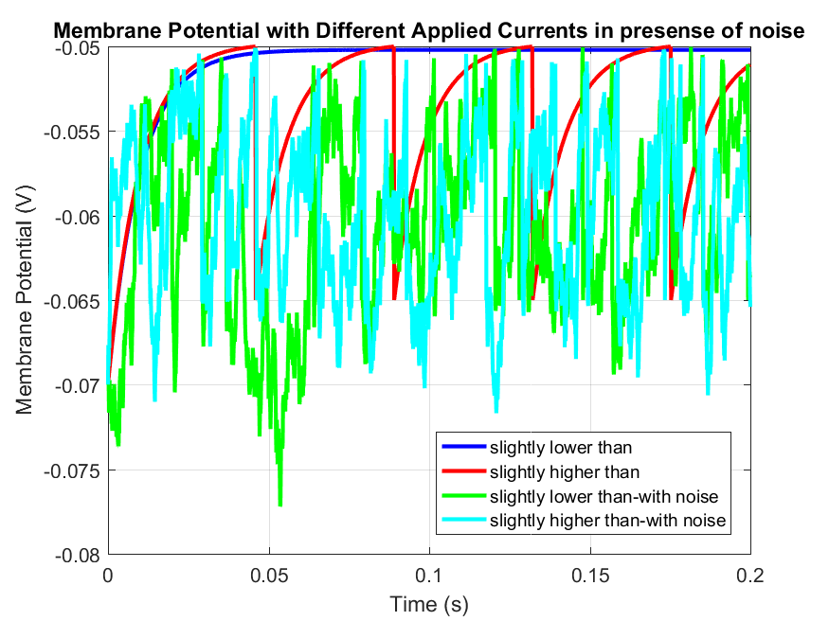

Adding noise with variance 0.1

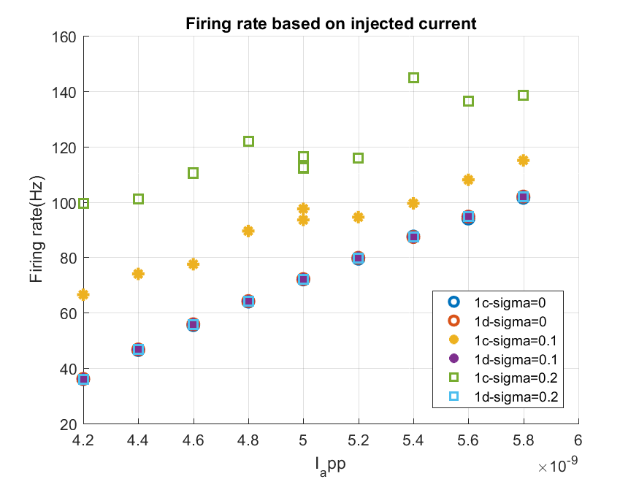

I can observe that the theoretical graph will be same in presence of noise but the estimation based on number of spikes will be change radically. also an increase in the parameter sigma, which is proportional to the standard deviation of the voltage noise, leads to an increase in the average firing rate when we use estimation based on number of spikes.

2c. changing dt to 0.01 ms:

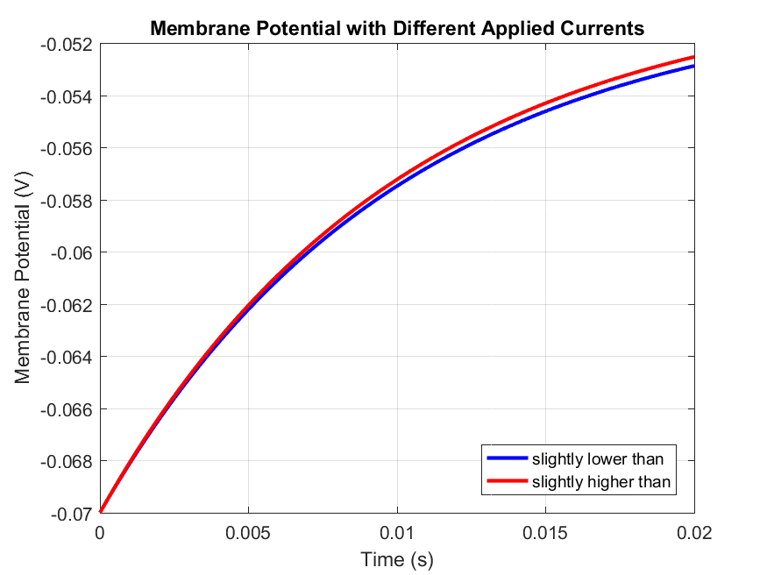

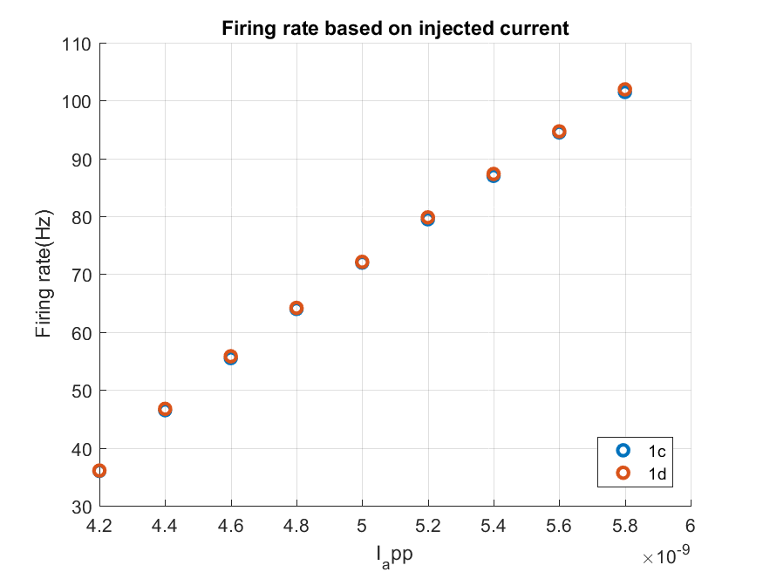

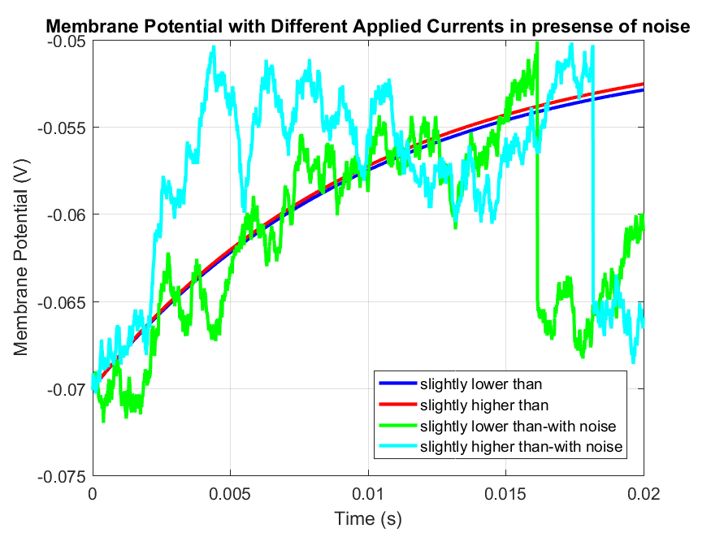

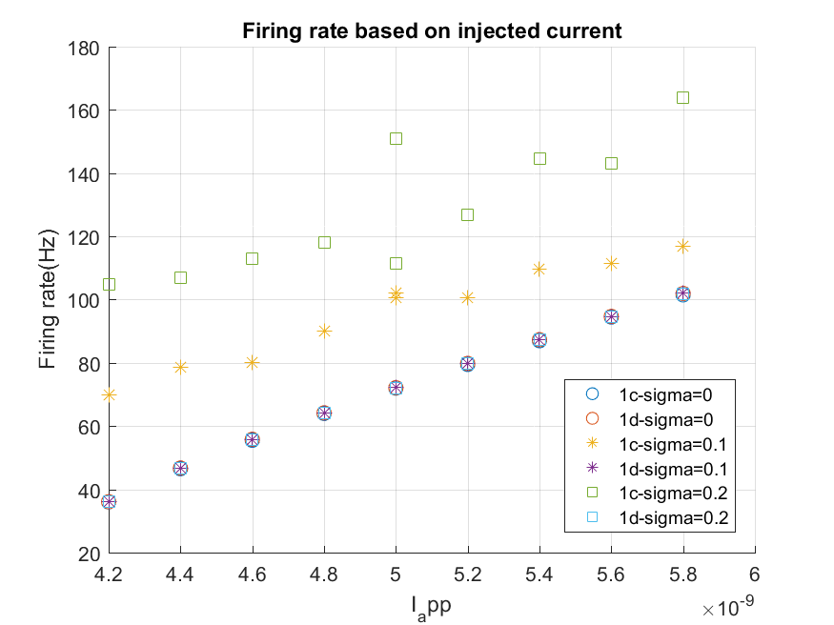

As we can observe in graphs a finer timestep allows for a more accurate simulation of membrane potential changes